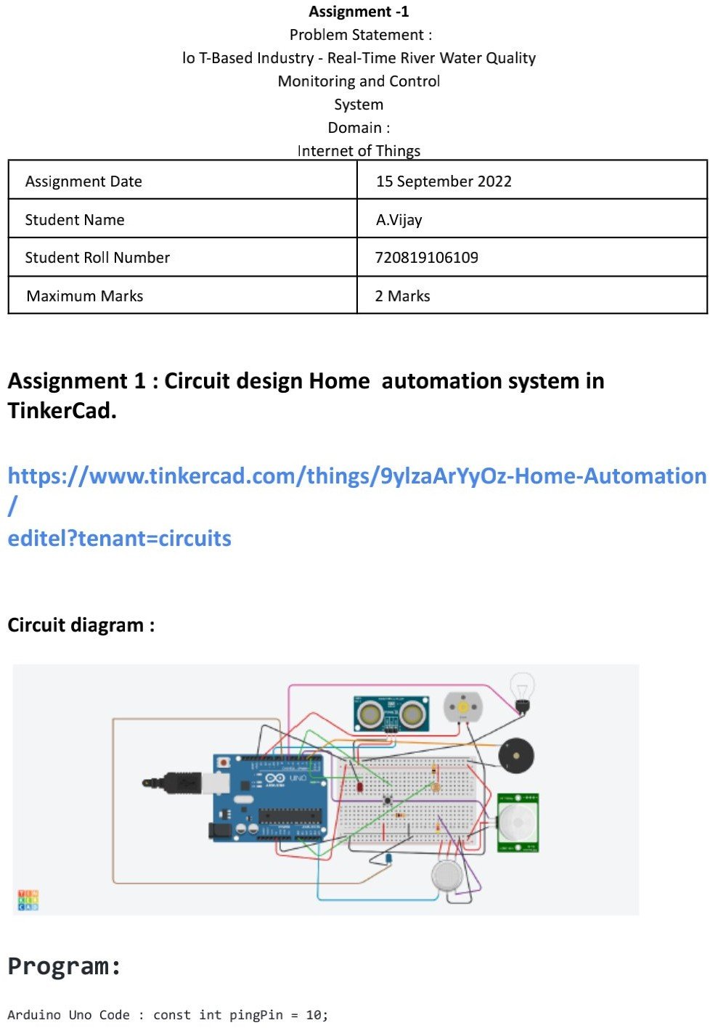

110719106019

M Venkata Pavan Kumar

M Venkata Pavan kumar

110719106019

110719106036

15 September 2022

2 Marks

V**.** MaheshBabu

